Pseudocode questions   
Q1

Start

Initialize variables

Num1, Num2, Num3

IF num1<num2<num3

THEN

print “num1 is smallest “

END IF

IF

num2<num3<num1

THEN

print “num2 is the smallest”

ELSE print” num3 is smallest “

END

Q3

Start

prompt “enter first number”

read first number

prompt “enter second number”

read second number

prompt “enter operator” (for multiplication (\*) for division (/))

read operator

IF operator is \*

result = first number \* second number

THEN print “result”

ELSE IF operator is /

result = first number /second number

THEN print result

END IF

END

Algorithm question   
q1   
if it is a prime number output true if not then false  
input number (n)  
if n <= 1 then output false   
if n is divisible by any number between 1 and n then output false   
if n is only divisible by 1 and n then output true   
q2  
ask the user to enter number from 1-365  
divide the number by 7   
if remainder is   
0 = Monday   
1=Tuesday  
2= Wednesday  
3= Thursday  
4=Friday  
5=Saturday   
6= Sunday  
output the remainders corresponding week day   
q3  
input number 1   
input number 2   
number 1 =a   
number 2 =b   
if a is 0 then gcd is b   
if b is 0 then gcd is a   
Otherwise replace a with b and b with the remainder when a is divided by b(a mod b)  
Repeat the above step until b becomes 0.  
The value of a at the end of the algorithm is the GCD of the original numbers  
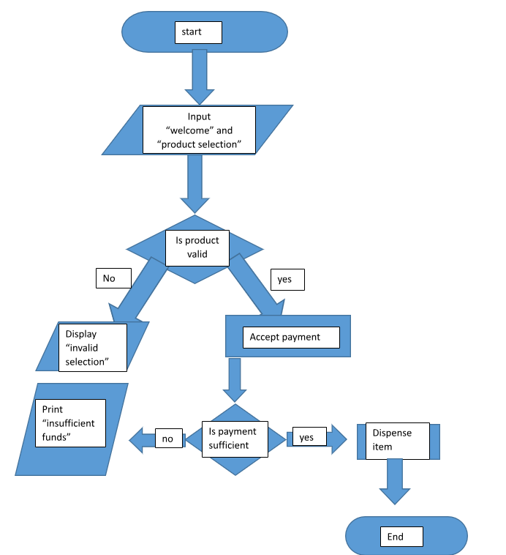

RECIVE PACKAGE

START

End

YES

NO

Deliver package

Load package

Handle package with care add fragile sticker

Is package fragile?

YES

NO

YES

NO

Sort package

Urgent packages finished?

IS DELIVERLY URGENT?

LOG PACKAGE DETAIL

Wait in queue

Prioritize package